Weapons and equipments

Kyūbi's dream

Description
From the twilight's wood tanned by foxfire's dance. Holds the whispered words.

Type
Kitsune mask

Feature
Shape-shift to Kyūbi (the first one-tail form)

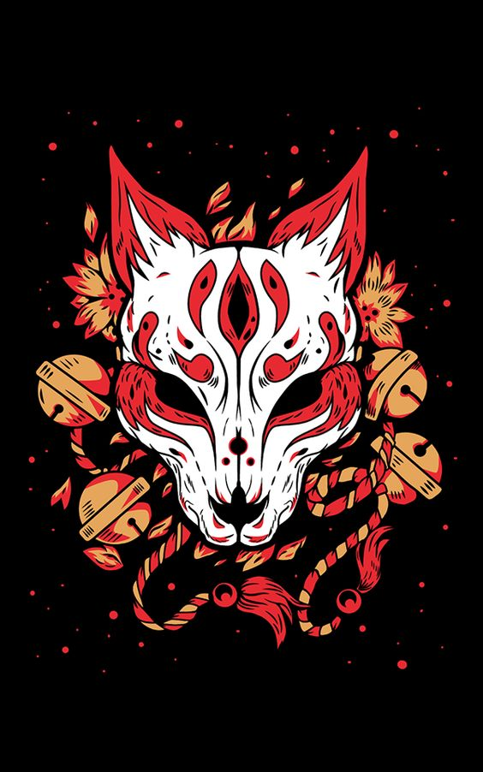
[Credits: Isrrael Bonifaz]

Hikari no Ōzakura (光の大桜)

Description
Blossoms with cherry flowers of stories you won't hear anymore.

Type
Katana

Feature
- Damage: 214 dps
- Attribute: +45 spirit
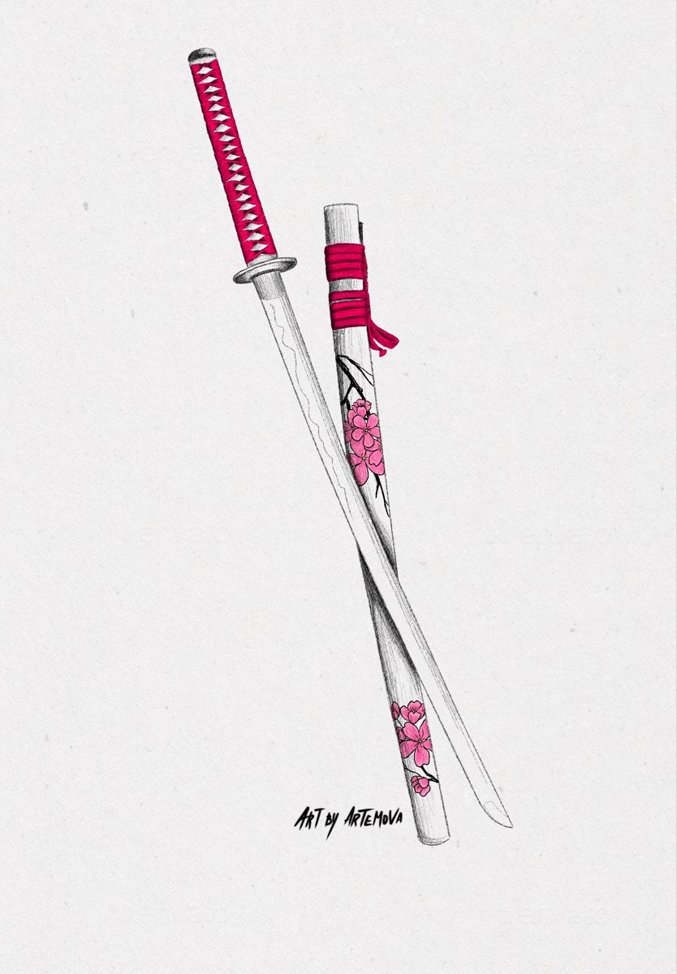
[Credits: Artemova]

